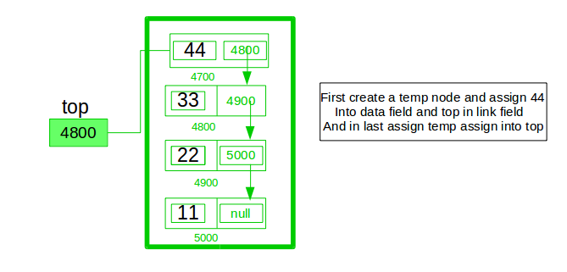

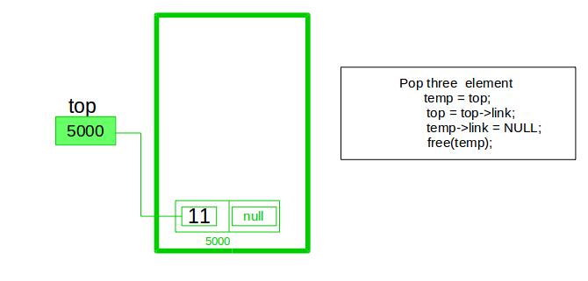

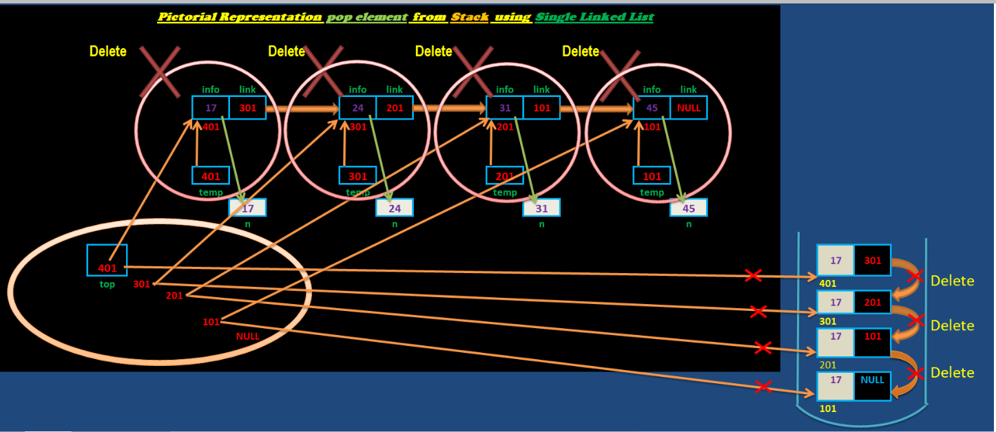

class Node:
def __init__(self, data):
self.data = data
self.next = None

class Stack:
def __init__(self):
self.head = None

def is_empty(self):
return self.head is None

def push(self, data):
new_node = Node(data)
new_node.next = self.head
self.head = new_node

def pop(self):
if self.is_empty(): # self.head is None:
raise ValueError("Stack is Empty!")
popped_node = self.head
self.head = self.head.next
popped_node.next = None
return popped_node.data

def peek(self):
if self.is_empty(): # if self.head isNone:
raise ValueError("Stack is Empty!")
return self.head.data

def display(self):
if self.is_empty():
print("Stack is empty")
else:
current = self.head
while current:
print(current.data, end=" ")
current = current.next
print()

# Example usage:
stack = Stack()
stack.push(1)
stack.push(2)
stack.push(3)
stack.display() # Output: 3 2 1
print(stack.peek()) # Output: 3
print(stack.pop()) # Output: 3
stack.display() # Output: 2 1
print(stack.is_empty()) #False

